**Practice 7**

1. Create and invoke the GET_JOB function to return a job title.

* + - 1. Create and compile a function called GET_JOB to return a job title.

CREATE OR REPLACE FUNCTION GET_JOB(p_job_id JOBS.JOB_ID%TYPE) RETURN JOBS.JOB_TITLE%TYPE AS

v_job_title JOBS.JOB_TITLE%TYPE;

BEGIN

SELECT JOB_TITLE INTO v_job_title

FROM JOBS

WHERE JOB_ID = p_job_id;

RETURN v_job_title;

END;

/

* + - 1. Call the created function from an anonymous block for the SA_REP job ID and print the result.

DECLARE

v_job_title JOBS.JOB_TITLE%TYPE;

BEGIN

v_job_title := GET_JOB('SA_REP');

DBMS_OUTPUT.PUT_LINE('Job Title: ' || v_job_title);

END;

/

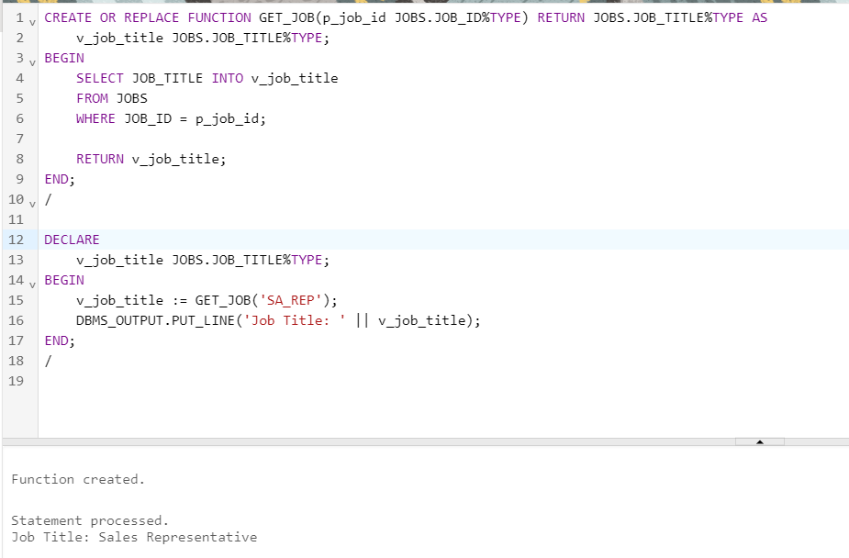

2. Create a function called GET_ANNUAL_COMP to return the annual salary computed from an employee’s monthly salary and commission passed as parameters.

a. Create the function, which accepts parameter values for the monthly salary and commission. Either or both values passed can be NULL, but the function should still return a non-NULL annual salary. Use the following basic formula to calculate the annual salary:  
 (salary*12) + (commission_pct*salary*12)

CREATE OR REPLACE FUNCTION GET_ANNUAL_COMP(

p_monthly_salary NUMBER,

p_commission NUMBER

) RETURN NUMBER AS

v_annual_salary NUMBER;

BEGIN

v_annual_salary := (NVL(p_monthly_salary, 0) * 12) + (NVL(p_commission, 0) * NVL(p_monthly_salary, 0) * 12);

RETURN v_annual_salary;

END;

/

1. Use the function in a SELECT statement against the EMPLOYEES table for employees in department 30.

SELECT employee_id, first_name, last_name, GET_ANNUAL_COMP(salary, commission_pct) AS annual_salary

FROM employees

WHERE department_id = 30;

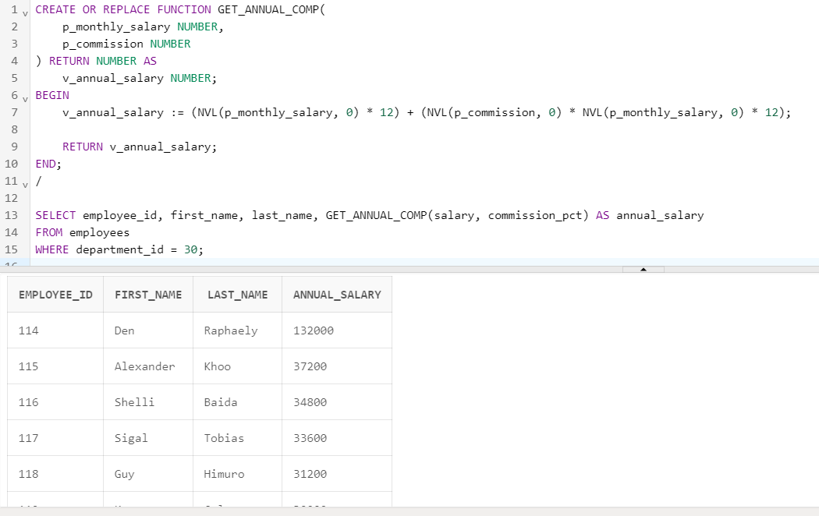

3. Create a procedure, ADD_EMPLOYEE, to insert a new employee into the EMPLOYEES table. The procedure should call a VALID_DEPTID function to check whether the department ID specified for the new employee exists in the DEPARTMENTS table.

a. Create a function called VALID_DEPTID to validate a specified department ID and return a BOOLEAN value of TRUE if the department exists.

b. Create the ADD_EMPLOYEE procedure to add an employee to the EMPLOYEES table. The row should be added to the EMPLOYEES table if the VALID_DEPTID function returns TRUE; otherwise, alert the user with an appropriate message. Provide the following parameters:

* + - * + first_name
        + last_name
        + email
        + job: Use ‘SA_REP’ as the default
        + mgr: Use 145 as the default
        + sal: Use 1000 as the default
        + comm: Use 0 as the default
        + deptid: Use 30 as the default
        + Use the EMPLOYEES_SEQ sequence to set the employee_id column
        + Set the hire_date column to TRUNC(SYSDATE)
      1. Call ADD_EMPLOYEE for the name Jane Harris in department 15, leaving other parameters with their default values. What is the result?
      2. Add another employee named Joe Harris in department 80, leaving remaining parameters with their default values. What is the result?

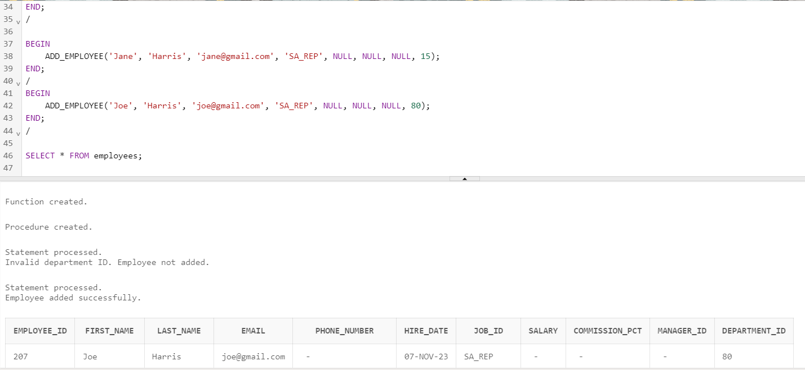

CREATE OR REPLACE FUNCTION VALID_DEPTID(

p_dept_id NUMBER

) RETURN BOOLEAN AS

v_dept_count NUMBER;

BEGIN

SELECT COUNT(*)

INTO v_dept_count

FROM departments

WHERE department_id = p_dept_id;

RETURN (v_dept_count > 0);

END;

/

CREATE OR REPLACE PROCEDURE ADD_EMPLOYEE(

p_first_name VARCHAR2,

p_last_name VARCHAR2,

p_email VARCHAR2,

p_job_id VARCHAR2 DEFAULT 'SA_REP',

p_manager_id NUMBER DEFAULT 145,

p_salary NUMBER DEFAULT 1000,

p_commission_pct NUMBER DEFAULT 0,

p_department_id NUMBER DEFAULT 30

) AS

BEGIN

IF VALID_DEPTID(p_department_id) THEN

INSERT INTO employees (employee_id, first_name, last_name, email, hire_date, job_id, salary, commission_pct, manager_id, department_id)

VALUES (employees_seq.NEXTVAL, p_first_name, p_last_name, p_email, TRUNC(SYSDATE), p_job_id, p_salary, p_commission_pct, p_manager_id, p_department_id);

COMMIT;

DBMS_OUTPUT.PUT_LINE('Employee added successfully.');

ELSE

DBMS_OUTPUT.PUT_LINE('Invalid department ID. Employee not added.');

END IF;

END;

/

BEGIN

ADD_EMPLOYEE('Jane', 'Harris', 'jane@gmail.com', 'SA_REP', NULL, NULL, NULL, 15);

END;

/

BEGIN

ADD_EMPLOYEE('Joe', 'Harris', 'joe@gmail.com', 'SA_REP', NULL, NULL, NULL, 80);

END;

/

SELECT * FROM employees;